TO: Dr. Derek G. Ross
FROM: Ashtyn Daniel
SUBJECT: Final Editing Report
DATE: April 28, 2026
In this report, I will explore what it means to be an editor through discussing my editing approach, editing exercises, and editing project. I will utilize literature, images, and links to my work to support my argument that editing is a collaborative and caring role.

My Editing Approach

Personal Editing Practices

Collaboration
Editing hinges upon “a departure from client centeredness toward a stakeholder-oriented approach in which the multiplicity of audience, context, and community must be foregrounded” (Lancaster and King, 2024, p. 27). In order to facilitate editing as a collaborative process, editors must consider the relationship between an author and their audience. Editors shouldn’t view their authors just as clients, but as people whose writing is filled with their opinions, biases, and experiences. I believe that part of collaboration via editing means understanding why authors want to appeal to their specific audience, and as an editor, considering how an audience might comprehend or react to an author’s work. Editors should challenge an author’s perspective and refine it to successfully appeal to their intended audience, while still retaining the author’s voice.

Author Care
Since I view authors as people and a co-participant in the editing process, “the social loyalties that participants have…determine the action chosen…” (Amare and Manning, p. 289, 2009). As an editor, social loyalties will depend on the editing project, author, and if the editor is employed by a company. As such, loyalties can shift depending on the editing job; in one situation, an editor might feel more obligated to an author and their work, but in another, they might feel more obligated to the company. As an editor not currently employed by a company, my social loyalty is to my authors. This loyalty means that when authors make mistakes, whether grammatically or content wise, I address them, because I care for them and their work, and value their progress. Caring for an author and their work for me also means knowing when I’m the right editor fit and when I’m not. Some authors might want an editor who’s less collaborative and more of an overseer. Because of this, editing with care means knowing when to not take on an editing job if and when I sense that my editing style won’t fit with an author, their work, and their needs.

Editing Exercises
Image 1: Creative Writing Exercise

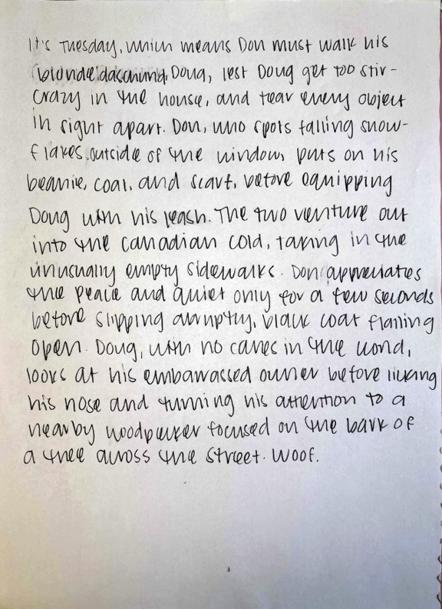
Line Editing

Creative Writing Exercise
In this exercise, I had to include a man walking a dog, wearing a dark/black coat, the man falling on an icy sidewalk, and the line “he licked his nose” in a paragraph. After writing, I edited a classmate’s work. Without further instruction, the editing was a vague task. I didn’t know what audience I was editing for. I didn’t know what to look for: spelling errors, coherency, structure, etc. My editing job was general, and not specifically tailored to my classmate’s needs.
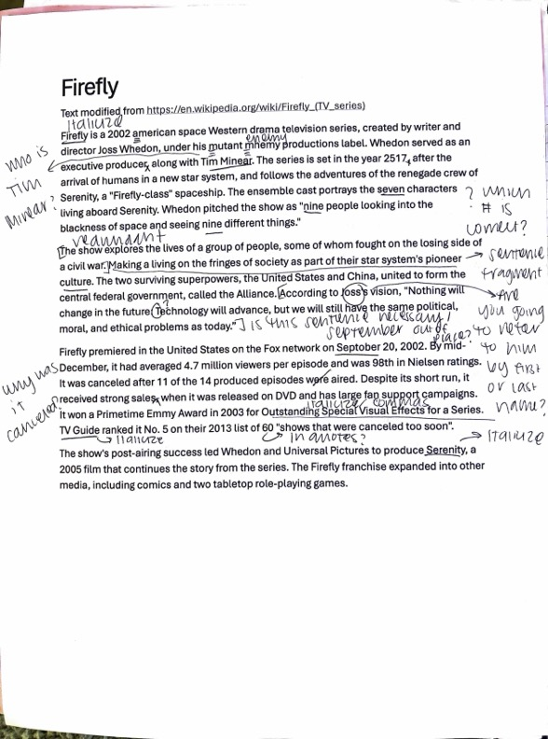
This exercise emphasized the importance of editor-author communication. Cunningham, Malone, and Rothschild (2020) emphasize that as an editor, “one of your goals must be to improve the communication by advocating for the reader or user and suggesting or making appropriate edits” (p. 23). Editors consulting with their clients before editing is important. Part of author-editor communication is laying out expectations of what the author can expect from an editor. Editors should ask their authors questions such as: What kind of edit do you want? What’s the purpose of this document? What message are you trying to communicate to your audience with this document? Without this clarity, editors and authors author might have varying ideas about what an edit entails and create confusion about editing expectations.
Image 2: Firefly Wikipedia Page

Firefly Wikipedia Page
In this exercise, I corrected errors from three sample paragraphs from the Firefly Wikipedia page. Whalen (1989) states that “even if the article is perfect… it will not make a contribution unless the message is clear to the readers” (p. 647). When editing, an editor must center the audience before themselves and imagine themselves as an audience member. Editors should think through what information the audience already knows, should know, doesn’t know, and doesn’t need to know. These considerations help editors understand what information is crucial, superfluous, and missing. Additionally, it hinders the author from centering their knowledge and overediting.
I found around twenty errors. There were only eleven errors, so I realized I was overzealous in my corrections. Instead of trying to make the information clearer to me, I should’ve thought through what mistakes would most hinder the audience’s understanding. I carried this centering of the audience with me through subsequent exercises.

Global Editing
Image 3: Page from Business Ethos Chapter

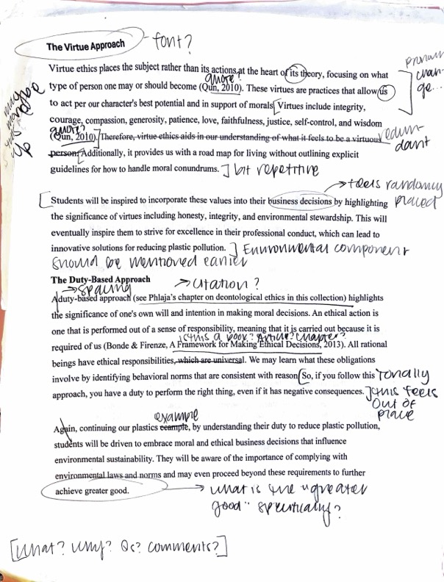
Business Ethos Chapter
In this exercise, I edited a chapter about ethical approaches business students can have regarding environmental sustainability. The chapter had issues regarding improper citations, grammatical errors, unclear tone shifts, formatting, and structure. There was vague wording and unclear sentence structures. What I thought, but didn’t yet have the theory to communicate, was that I was desiring plain language, which is designated by “if [a document’s] wording, structure, and design are so clear that the intended readers can easily find what they need, understand what they find, and use that information” (Cheung, 2017, p. 13). Plain language emphasizes that text is not only useful, but usable. It’s not enough that a text accomplishes its goal of discussing a topic. An audience must be able to convert that topic into skills like critical thinking. Plain language also erases academic jargon. Even if documents don’t mean to, jargon can increase the threshold of knowledge a reader must have, which can create a barrier to education. This lessens the accessibility of academia, by gatekeeping information instead of sharing it.
Since my Firefly exercise attuned me audience needs, I edited for audience clarity and understanding, such as suggesting new sentence structures. Also, this chapter was co-authored by an undergraduate student with limited professional academic writing experience and a professor who was familiar with this kind of writing. Because of this, the language was inconsistent, and I emphasized less jargon in my edits. This exercise underscored that when working with multiple authors, it’s important to ensure that their voices and writing styles blend together.

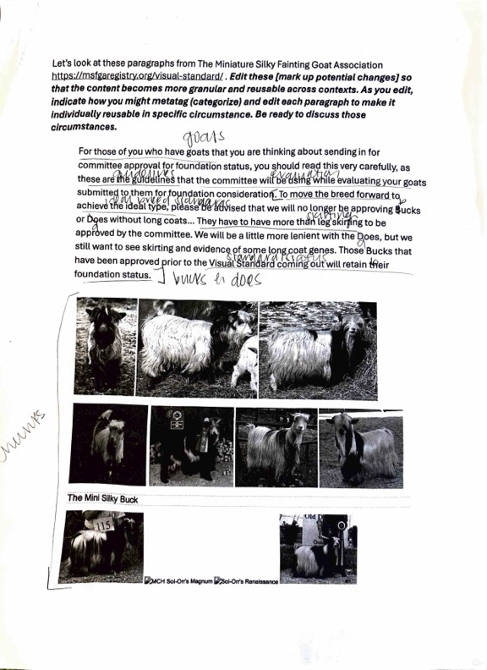
Chunking

Miniature Silky Fainting Goat Association Exercise
Image 4: Page from Chunking Exercise
In this activity, I chunked information from The Miniature Silky Fainting Goat Association about goats and does. Chunking is important because “people require that information be organized and conveyed effectively; computers require that it be tagged properly with metadata” (Cunningham, Malone, and Rothschild, 2020, p. 255). Editing for multiple formats requires thinking about information arrangement. With computers, audiences are less inclined to read large blocks of text, so chunking aids editors by stressing what information is central to the audience for a particular context. If there’s a lot of material on one particular subject for instance, it’s worth considering having a heading devoted to that. Or, if there’s multiple aspects of a specific subject, then it might be worth formatting that information in bullet points.
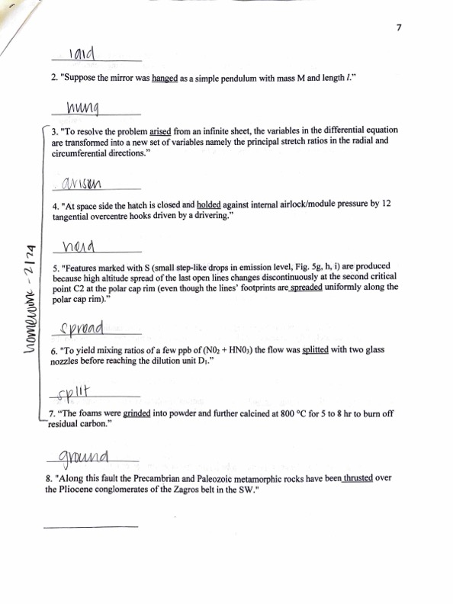
Reading the document a couple of times emphasized some of its main ideas, and allowed me to chunk them. Some of the chunking groups I created were “standards,” “mini silkies,” “coat,” and “ears/ear set.” After chunking, it became easier to figure out how to present the information. Some sentences could be shifted from one paragraph to another, and headings and bullet points could be introduced so that the document was sectioned and more readable. For example, I could have a single page devoted to coat types, or I could have a page dedicated to physical qualities of goats and does including coats and ears. This exercise visualized how information can be condensed to enhance an audience’s understanding of content.
Image 5: Page from Grammar Packet

Copyediting

Grammar Packet
To practice copyediting, I did various grammatical exercises. Some were focused on matching verb tenses or on identifying different verb tenses (simple, perfect, and past perfect). Copyediting is important because it’s “editing to ensure correctness and consistency; conformity to guidelines or specifications; and accuracy and completeness” (Cunningham, Malone, and Rothschild, 2020, p. 281). Copyediting isn’t subjective, since there’s grammatical rules assisting the editor. As such, there’s less wiggle room for what’s right and wrong. For publications, qualities such as accuracy regarding copyediting are integral because you cannot build an audience or authorship if you don’t adhere to standards that ensure consistency in your work.
The editing packet was an interesting experience. I’m apt at identifying comma splices, spelling errors, or other simple grammatical issues. However, I found myself becoming confused and second-guessing if I was deleting or adding to the number of errors as I did more exercises. While this type of editing is obviously needed, it wasn’t in my wheelhouse of editing skills.

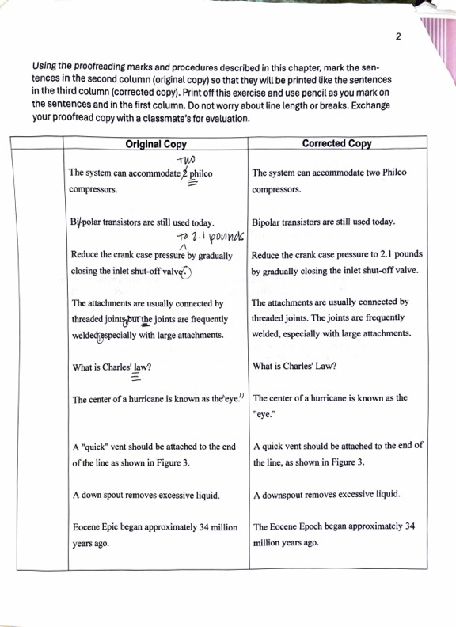
Editing Marks
Image 6: Editing Marks Packet
Another copyediting exercise involved utilizing editing marks. When marking sentences, I realized quickly how limited my knowledge was. I only knew the symbols for insertions, deletions, and capitalization. There were so many times when I wanted to communicate something, such as transposing words, but I couldn’t because I didn’t know the correct symbol. However, because these marks are widely used, I want to memorize them.
Copyediting is useful because in theory, you just have to learn more about grammar. However, it’s dependent upon conventions such as standard English. As such, it can reinforce the gatekeeping that plain language is against if not carefully utilized by an editor.

Content Editing

Myotonic Goat Registry Exercise
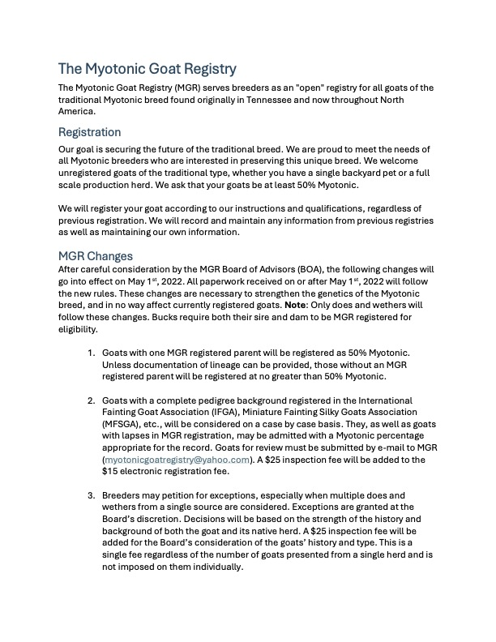
In this exercise, I edited information from the Myotonic Goat Registry website for clarity and organization. I ensured that my changes centered on audience, purpose, and context. The audience was those familiar with Myotonic goats, but not familiar with the MGR registration process. The purpose was to clarify and detail MGR’s registration process. The context was that this information belonged on the MGR website and needed consistency with other website content.
Image 7: Myotonic Goat Registry Exercise
I simplified the document’s language and sentences to lessen confusion. There were multiple syntax problems, so I rearranged sentences and introduced section headings (“Registration” and “MGR Changes”) into the document for clearer organization. I inserted alt text onto the photo of the Myotonic goat. Digital Accessibility Services defines alt text as being “read by screen readers (or other assistive tech) to provide information about the image to the reader.” Alt text is important for editing, as an editor should consider a document’s accessibility. With online content, accessibility is often overlooked because able-bodied individuals believe that online content is accessible since there’s seemingly no barriers to internet access. However, screen readers emphasize that online content should be metatagged and as descriptive as possible so that even without hearing or seeing content, it can still be understood and used.
My knowledge of chunking from The Miniature Silky Fainting Goat Association activity guided me regarding utilizing document subheadings, bullet points, and sectioning my paragraphs. My main goal was to make the document as readable as possible, so I included more white space in between paragraphs and sections so the text wasn’t visually overwhelming.

Layout and Design Editing

Absentee Ballot Application
Regarding layout and page design, I filled out an absentee ballot application for Lee County. A problem with these ballots is that “[absentee voters] do not interact with poll workers, voting equipment, or other voters at the polls…” (Bryant, 2020, p. 700). Interaction and collaboration are the basis of editing. Because voting is a form of publishing, that has legal ramifications, the lack of clarity within absentee ballots confines editing to a solitary process. Voting itself is an editorial process because a document is published at the end of it, so poll workers are editors. Similar to editors, poll workers have expertise, but with voting. They guide voters and prevent errors that invalidate voting forms. Absentee ballots make voters the editors, without the expertise needed to accurately assess and fill out ballots, which leads to confusion. These issues extend to applications as well.
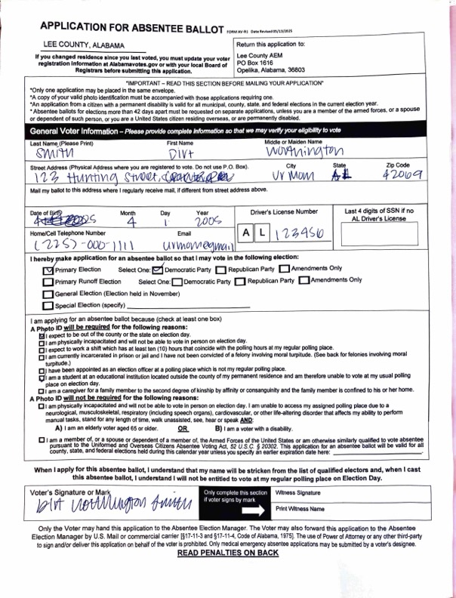
When I filled out the form, I became confused. On the address line, I wrote the information together, and then realized that there were separate spaces for the street address, city, state, and zip code. To request the right ballot, I had to check what election I wanted to vote in but also check my party affiliation. The boxes for the elections and party affiliations were consecutive, so I wasn’t sure what I needed to check. One section needed to know why I was requesting an absentee ballot. Some reasons were repetitive; “I expect to be out of the county or state on election day” and “I am a student at an educational institution located outside of my county of my permanent residence and am therefore unable to vote at my usual polling place on election day” are conveying similar information. One acceptable reason to request an absentee ballot mentioned not being “convicted of a felony involving moral turpitude.” When the application was turned over, a long list of crimes that counted as “involving moral turpitude,” was present, which was overwhelming. From this exercise, I learned to use plain language and ensure that my documents have a navigable design to eliminate user confusion and errors.
Image 8: Absentee Ballot Application

InDesign Tutorial
Image 9: Page from InDesign Tutorial
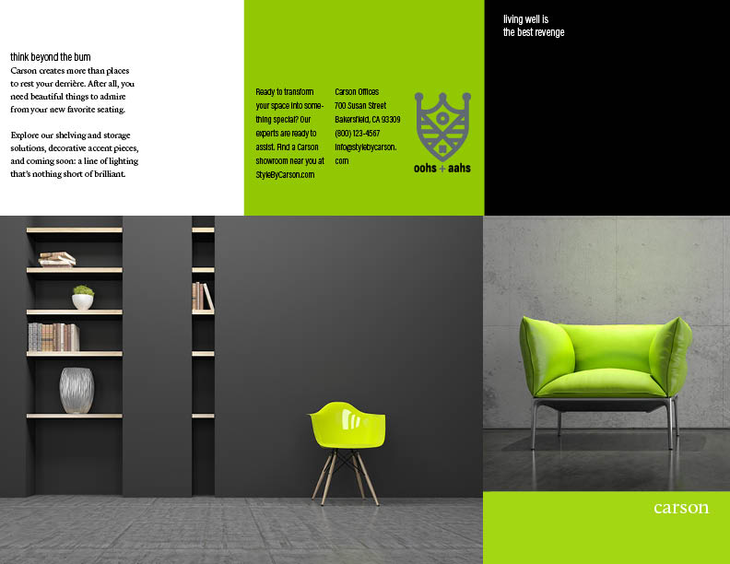
When I last did the InDesign tutorial, I approached it from a designer perspective, ensuring that design principles were met. When doing the tutorial this time, I was more focused on how InDesign can help with layout. This tutorial helped me understand how to create cohesiveness when a publication requires a consistent design across multiple pages, which was useful for my design project.

Editing Project

Project Idea
When creating the editing project, it was an insightful peek behind the curtain. One of the steps for problem solving is define, or “clearly articulat[ing] the problem you want to solve” (Lancaster and King, 2024, p. 22). For any project, it’s important to center the idea at every stage of project development. An idea serves as a solution to the problem of, “What is the publication, who does it serve, and what does it do?” These questions allow editors to consider if their publication idea has an identifiable audience, purpose, and context. If so, then the idea is most likely feasible, and can be achieved. However, ideas can and should adapt as editors consider how to best produce a quality publication within a time constraint.
We worked backwards to try and identify our audience, purpose, and context, to see if we generated an idea. At first, our audience was any student or faculty member in the English Department. Then, we realized that trying to reach undergraduate students is a conflict of interest, as some are our students, which could lead to ethical quandaries. So, we limited our audience to English graduate students and faculty. Our purpose was showcasing cultural and familial recipes. Our context was cataloguing the different cultures within the English Department via recipes. From these three aspects, our idea was a booklet of recipes from English graduate faculty and students featuring a cultural or familial tie.

Choosing Group Roles
We based our roles off of interest and skillset. I was the Editor-in-Chief. My role involved sending out our Call for Papers and managing the submissions we received. However, as time went on, my role as Editor-in-Chief shifted to be less of an overseer and more of a collaborator with my group.

Mission Statement
Braun et al. (2012) states that “the core of effective mission statement development and implementation is its alignment with given organizational structures and involvement” (p. 439). Mission statements should clearly define who’s a part of the organization, how the publication reflects the values of the organization, and why an organization matters. For a project, the organization might be a group. For mission statements to succeed, they must create and reinforce a cohesive and distinguishable identity for the publication. If not, authors won’t know if their values align with a publication, which could prevent submissions. Audiences won’t know what a publication’s goal is, and might not read it. As such, having a clear mission statement is integral.

First Draft
For our first draft, we created a feeling rather than clarifying how our mission statement connects to our audience, purpose, context, and authors. We stated that “our publication is a project born from the sincere desire to build community through the connection of culture and to prompt vitality and storytelling through food.” However, this doesn’t explain what the publication is, which wasn’t helped by our lack of a title. We continued this vagueness with statements like “Created within the English Department community at Auburn University, this publication values learning.” We’re not introduced, so authors don’t know who they’re submitting to. However, we did somewhat create a brand identity with sentences like, “Regardless of skill level, everyone is a chef, and we can all learn about and from each other in the kitchen,” which conveys openness, learning, and curiosity.

Revised Draft
We revised our first draft heavily. We listed the title of our publication, Stories We Stir: What Feeds Us, so that there was an identifiable brand for our publication. We created a masthead that listed our names, and stated what Stories We Stir was, which was a recipe booklet. We specified that our authors are English graduate students at Auburn and that we wanted them to submit cultural and familial dishes. With this version of the mission statement, our audience, purpose, and context for our publication was clear. From creating the mission statement, I learned how important it is to convey the vision and goals of a publication. Without them, the target audience, both in terms of readership and authors, can’t be reached, and the publication won’t have a recognizable brand identity.

Style Guide
Style guides create cohesion within a publication. Adhya (2015) explains, “An organization’s content, including its Web site, blogs, manuals and press releases create and nurture a strong brand if it is refreshing and consistent” (p. 186). For editors, style guides are the baseline for how a publication will look both externally and internally. For external style guides, editors provide guidelines to authors for their content’s formatting. For internal style guides, editors provide a streamlined editing process for co-editors and reviewers. The consistency both types of style guides promote is integral because if a publication has a recognizable look, then its identity is legitimized. The publication then has credibility, which establishes both a solid readership and author pool.

First Draft
We took inspiration from examples of cookbook style guides we found online. These examples guided us on how we wanted our ingredients to be written out (ex. 1 Teaspoon of Salt) and how we wanted our family stories to be formatted (no more than 300 words). The most challenging part was figuring out what information to include. We anticipated questions our authors would have ahead of time, so I included notes, like putting a registration mark after brand names and starting off directions with action verbs (“Let x soak for…,” etc.).

Revised Draft
We received suggestions on more intentionally ordering the style guide. Our classmates weren’t sure what information was for authors and editors. Additionally, we received feedback that we should reconsider how much work our authors should do before they submit to us. We had very specific guidelines, such as requiring that headings be in 12-point font and that body text be in 10-point font. Our classmates were concerned that our authors would see the amount of formatting they would have to do and be discouraged from submitting.
For revisions, I separated our style guide into sections for authors and for editors and created a table of contents with these headings. This delineation illuminated what guidelines were for our authors and what guidelines were for us as editors. We decided author submissions should be 12-point Times New Roman. We expanded our family stories to be 150 words long; originally, they were 75, but our classmates stated that that length was probably too short. I standardized our author suggestions, using action verbs (“Start your blurb with your connection with the food” instead of “Don’t start your blurb with ‘This recipe/this dish is…’”). For the editors section, we decided 16-point Times New Roman for recipe titles, 12-point Times New Roman for body text, and 10-point Times New Roman for footnotes. I also added a section describing some ideas for our layout.

Call for Papers
Creating our CFP was another lesson in editing for our authors. Albornoz (2025) believes that CFPs “seek to attract the best possible submissions in their area of interest” and “place special attention in noting why the theme they are advertising is relevant” (p. 5). CFPs exist for editors to find authors whose interests match with a publication’s theme. With many publications covering similar subjects, CFPs distinguish one by underscoring what features make it unique. CFPs serve as the first encounter authors have with the publication, and are often the first marketing tool for a publication. As such, it’s important that CFPs are clear and accurately represent a publication.

First Draft
Our CFP included seven sections: “About the Publication, “Submission Email for A Recipe Template,” “Solicitation Poster Attached to The Email & Sent out to GroupMe,” “The Submission Receipt Confirmation Email Template,” “Acceptance Letter Template,” “Rejection Letter Template”, and “Revision Request Template.” The “About the Publication” section included a condensed mission statement, submission eligibility information, and a condensed style guide. We included the submission deadline and where to submit, which was to my email. The other sections were information relevant to us editors. It included two CFP templates, one for email and one for our cohort’s GroupMe, that I would send out. The other templates were for me to email once I received and read submissions.

Revised Draft
We received similar feedback like what we got on the style guide. There were consistency errors; on one page, the family stories had a 150 word maximum and then on another page, the maximum was 300 words. Additionally, the internal email templates weren’t needed, because that wasn’t for our authors. After we received this feedback, we edited our CFP to be shorter and have more consistency, like with the family stories word count. For eligibility, I included a note that authors could submit multiple submissions, as that was a question that arose during our critiques. Since I was sending out the CFP, I also removed the email templates, and included our full style guide for ease of access, so that our authors wouldn’t have to pull up two individual documents.

Collecting and Managing Submissions
NYU Libraries states that when receiving submissions, there has to be “time for calls to be open, editors to review, desk rejections and reviewer requests to be sent, reviews to be collected, decisions to be made, communications with authors about reviews, time for revisions, final editorial decisions, copy editing, as well as preparation for publication.” For editors and their reviewers, this is the busiest time regarding the process of publication. While style guides and CFPs help shape a publication’s identity through aesthetics and marketing, author submissions shape publication identity too. Accepted authors indicate how diverse a publication is regarding race, ability, gender, age, and more. An author’s voice and opinions are endorsed by a publication via acceptance, and can privilege the identities they inhabit. With these considerations in mind, editors should use discernment during the acceptance process and keep the reputation of the publication in mind.

Collecting Submissions
I sent out our CFP via email and GroupMe on Monday, March 2. Because Spring Break was the following week, we didn’t want to try and gather submissions during that time. Additionally, the submission deadline was March 24, so we wanted to give authors as much time as possible to formulate their recipes.
Less than a week after I sent this out, we received a few submissions. We were optimistic… until about a week and a half from our submission portal closing. We only had the three or so submissions we received. We decided we needed to reach out to people directly, because that was the easiest way to incentivize them to submit. This method was much more effective than my initial email and GroupMe message; from this, we received two submissions from professors and three submissions from graduate students.

Managing Submissions
After receiving submissions, I emailed the authors to notify them that I received their recipe. The email templates were a quick and standardized way of streamlining this confirmation process. Because of our style guide, it was easy determining if an author’s submission followed it or not. While I had an idea of what submissions I wanted to accept, I still had to run them by group. I created a Box folder to share submissions, which we agreed on. They reviewed six out of our eight submissions in total; I received two on the deadline day, and so as Editor-in-Chief, I made the executive decision to accept those submissions based on my judgment, so as to not add more work to my group members. All in all, we accepted all eight of our submissions, and I notified the authors of their acceptance.

Design

First Draft
For our layout, we wanted the recipe title, author name, picture, and family story on the left page. On the right page, we wanted the steps, directions, and notes. For the page type, we decided on Letter – Half, portrait. For the background, we thought that it would coincide with our scrapbook theme if our pages had different backgrounds. To justify this, we agreed that the page formatting would be the same.
Regarding design and collaboration, Anderson et. al (1998) recounts an experience with a team redesigning a website and notes that “the editors agreed roughly on many issues but differed when applying those decisions on particular pages; so variations appeared in graphics, frames, background and text colors, and titling” (p. 476). Additionally, Anderson et. al (1998) notes that the team didn’t utilize a style guide, which contributed to their issues (p. 476). This situation underscores how important team communication is. The editors were focused on the design, but communicated on what they were designing instead of how they were designing. If the editors were more transparent about their designing process, then the design incongruities could’ve been avoided. Additionally, with so many different design elements, project management and execution is much easier when there are style guides to adhere to. They ease the design process by staying organized. This scenario happened to my group; we had discussed what we wanted to do, but didn’t communicate about what we did. We also didn’t reference our style guide, which lead to our classmates pointing out varying fonts, layouts, photo sizes, page sizes, and headings (“Steps” vs “Instructions” vs “Directions”).

Revised Draft
For the heading font, I suggested Fredricka the Great, as the handwritten quality of it communicated a scrapbook aesthetic. For the body text, we chose Georgia (Regular) so that we could mirror the Fredricka’s serif quality. We also decided to adhere to the layout that we decided at our initial design meeting. For the workload, we all decided to work on one aspect of the revisions. My role was to work on removing the white space from our stock illustrations, and I also did a substantive edit before our second round of critiques. According to Van Buren and Buehler (1976), “The [substantive] editor ensures that the publication contains all of the report elements required for a complete presentation of the material, noting gaps, transpositions, and redundancies” (p. 25). Substantive edits often involve other types of edits, such as type and formatting. Because of their depth, they are more time-consuming than just editing one element. As such, it can be difficult to try and address all the potential issues a publication may have in one editing pass. Substantive editing is usually done by focusing on one element at a time, so that it’s not overlooked. I used this technique, and it attuned me to issues I didn’t originally recognize, such as the placement of our page numbers. My substantive edit included me titling our recipe headings the same, aligning page elements, correcting page numbers, placing photos on the same places on pages, ensuring font consistency, and fixing the layout of our pages.
When we had our second round of critiques, our group felt much more confident about our booklet. Our classmates felt that we adequately addressed their concerns, and we felt proud of our work. The only concern we had was that on our second print, which was higher quality than our first print, the printer changed the alignment and typeface of our pages. Currently, we’re working on publishing our booklet to our authors.

Takeaways
A publication can quickly come together. At the beginning of the semester, I doubted that I would have a physical publication in fifteen weeks. However, when I look back at the progress my group and I made, I can see how feasible it is. We regularly met and communicated about what tasks needed to be done and even though our products weren’t perfect, what mattered the most is how we kept our shared vision of what Stories We Stir was at the foundation. We believed in our ability to create community with our recipe booklet, which kept us motivated. Additionally, the bond my group and I formed enabled us to do work we were proud of. Our workstyles complimented each other, and we prioritized respect and care for one another and our work above all else.
Through in-class discussions, I realized that both editors and authors alike have situations that directly impact the editing process. Editor illness, printing errors, and author inexperience are some of the issues we discussed. None of these could be avoided, but instead had to be approached with understanding the capacities of all involved. There was compromise in some situations, but in others, recognition that a solution that satisfied every party involved didn’t always exist. As such, I learned that protecting the energy of fellow editors, reviewers, and co-workers is just as important as protecting an author’s voice when editing their work.
Lastly, editing is deeply personal. While you can try to remove your emotions from your editing, it can’t be done. To edit is to connect with an author, which is a deeply human experience. As such, editing should, and often does, lean into that connection. During the exercises I did, I tried to be as “neutral” as possible. However, I realized quickly that there were prejudices I harbored that favored certain writing styles over others (such as with the Firefly exercise). I uncovered my bias against more clinical writing, which arose from my experience as a creative writer. I learned how to better work with it (like in the Business Ethos Chapter exercise), which expanded my editing skillset. Additionally, some of these prejudices came in the form of not making documents as accessible as possible, but once I realized my weakness in this area, I became more intentional about incorporating accessibility.
Overall, my experience in this editing class has endowed me with a newfound appreciation and skillset regarding editing. I’m excited to take my lessons from this class and apply them both personally and professionally.

References
Adhya, E. (2015). Key Elements of an Effective Style Guide in the New Age. Technical Communication, 62(3), 183–192. https://www.jstor.org/stable/26464421
Albornoz, J. P. (2025). The Overlooked Genre of Calls-for-Papers: New Grounds to Study Shifts and Connections in Academic Discourse. Journal of Open Humanities Data, 11(18), 1–14. https://doi.org/10.5334/johd.278
Amare, N., & Manning, A. (2009). Examining Editor-Author Ethics: Real-world Scenarios from Interviews with Three Journal Editors. Journal of Technical Writing and Communication, 39(3), 285–303. https://doi.org/10.2190/tw.39.3.e
Anderson, S. L., Campbell, C. P., Hindle, N., Price, J., & Scasny, R. (1998). Editing a Web Site: Extending the Levels of Edit. IEEE Transactions on Professional Communication, 41(1), 473–483. https://doi.org/10.1109/47.661630
Braun, S., Wesche, J. S., Frey, D., Weisweiler, S., & Peus, C. (2012). Effectiveness of mission statements in organizations – A Review. Journal of Management & Organization, 430–444. https://doi.org/10.5172/jmo.2012.1761
Bryant, L. A. (2020). Seeing Is Believing: An Experiment on Absentee Ballots and Voter Confidence: Part of Special Symposium on Election Sciences. American Politics Research, 48(6), 700–704. https://doi.org/10.1177/1532673x20922529
Cheung, I. W. (2017). Plain Language to Minimize Cognitive Load: A Social Justice Perspective. IEEE Transactions on Professional Communication, 60(4), 448–457. https://doi.org/10.1109/tpc.2017.2759639
Cunningham, D. H., Malone, E. A., & Rothschild, J. M. (2020). Technical Editing: An Introduction to Editing in the Workplace. Oxford University Press.
Journal Publishing: Editorial Process. NYU Libraries. (n.d.). https://guides.nyu.edu/journal-publishing/workflows/process
Lancaster, A. L., & King, C. S. T. (2024). Amplifying Voices in UX: Balancing Design and User Needs in Technical Communication. State University of New York Press.
Van Buren, R., & Buehler, M. F. (1976, March 1). The Levels of Edit. Pasadena, California; NASA.
Whalen, E. (1989). Why We Edit. American Journal of Roentgenology, 152(3), 647–649. https://doi.org/10.2214/ajr.152.3.647
Write helpful Alt Text to describe images. Digital Accessibility Services. (n.d.). https://accessibility.huit.harvard.edu/describe-content-images

